The use of statistical methods in management research: suggestions from a case study
1 June 2009
Michael Wood
michael.wood@port.ac.uk .

This is beginning and end of a working paper / preprint. The full version is at:
http://userweb.port.ac.uk/~woodm/papers.htm

I’d be very grateful for any comments.

Introduction
The aim of this article is to consider the role which statistical methods can sensibly take in research, and to look at some of the difficulties with typical uses of statistical methods and possible approaches to reducing these difficulties. My approach is to focus on an article published in the Academy of Management Journal (Glebbeek and Bax, 2004), consider the value and limitations of the analysis, and to make some suggestions about alternative approaches to the analysis and presentation of the results.
There are obvious problems in generalizing from a single example. However, I argue below that a detailed analysis of a single case is essential for demonstrating and exploring the possibilities.
….

Conclusions and recommendations
We have looked in detail at just one research article. The conclusions which might be derived from another article would doubtless be slightly different. However, it is possible to formulate the following general suggestions, which are illustrated by Glebbeek and Bax (2004), but which are likely to be of wider applicability. These are described as suggestions, and prefaced by the word “consider”, to emphasise their tentative status.
- Consider whether any statistical approach is likely to be useful. The advantage of statistical methods is that they enable us to peer through the fog of noise variables to see patterns such as the curve in Figure 1. But for a statistical analysis to be worthwhile it is necessary to check four issues: whether the necessity to focus on easily measurable variables damages the credibility of the results, whether the target population is likely to be of lasting interest, whether the amount of variation explained is likely to be sufficient to justify the effort, and, taking these factors into consideration, whether the research makes a useful addition to existing knowledge. In the case of Glebbeek and Bax (2004), the variables – staff turnover and performance – are certainly of interest. However, it is arguable that the target context is a little restricted, that the proportion of variation explained is on the low side, and that the extent of the addition to current knowledge is debatable.
- Consider avoiding research aims which simply comprise a series of hypotheses to test. Instead, the aim should be to assess the relationship between variables – as numerical statistics and/or in the form of graphs. In the case of Glebeek and Bax (2004) this would lead to Figures 1 and 2, and Table 2 above. These have the advantage of provided a far more direct and user-friendly answer to questions about the effects of turnover, and the control variables, on performance. Conventional quantitative research based on null hypothesis tests is often strangely non-quantitative because readers are told very little about the size of impacts, differences or effects.
- Consider using confidence intervals to assess the uncertainties due to sampling error – e.g. Table 3 and Figure 4 above. These tell readers about the size of the effects (impacts on performance), and the likely uncertainties due to sampling error, in a far more useful way than null hypotheses and p values.
- Alternatively, if formal hypotheses are to be evaluated, consider using confidence levels for this purpose. For example, in the model in Table 3, the confidence level for the hypothesis that the impact of Turnover is negative is 99.65%. This can easily be worked out from the corresponding p value. Such confidence levels avoid a hypothetical and potentially confusing null hypothesis. (And, for the purists, problems over the interpretation of confidence levels can be resolved by viewing them as Bayesian credible intervals with flat priors, so quibbles about the distinction between confidence and probability can be ignored.)
- Bootstrap methods may be helpful for estimating confidence levels in a transparent and flexible manner. The confidence intervals in Table 3 can be produced by bootstrapping, as can the graphs in Figures 3 and 4 (which were produced by spreadsheets linked to http://userweb.port.ac.uk/~woodm/BRLS.xls). Figure 3, based on five bootstrap resamples, shows in a very direct manner how much the results from several samples from the same source might have varied. Bootstrap methods may be more powerful in the sense that they are sufficiently flexible to be adapted to the question at hand: it is difficult to see, for example, how the 65% confidence level for the inverted U shape hypothesis for the model in Figure 1 could have been obtained from conventional software and methods. The same method could obviously be extended to other hypotheses about the shape of functional relationships (e.g. those in Shaw et al, 2005).
- How easy to understand are readers likely to find the results? Consider reformulating results to make them more user-friendly – perhaps by giving brief descriptions of the interpretation of parameters, or by using parameters which have an interpretation which is as simple and directly useful as possible (e.g. unstandardised instead of standardised regression coefficients), or perhaps by using graphs more than is customary. I have tried to do this in relation to Glebbeek and Bax (2004) in Tables 2-4 and Figures 1-4.

References
Glebbeek, A. C., & Bax, E. H. (2004). Is high employee turnover really harmful? An empirical test using company records. Academy of Management Journal, 47(2), 277-286.
Shaw, J. D., Gupta, N., & Delery, J. E. (2005). Alternative conceptualizations of the relationship between voluntary turnover and organizational performance. Academy of Management Journal, 48(1), 50-68.

Table 2. Parameters for the model in Figure 1
 | Best estimate
Location of optimum (annual % staff turnover)* | 6.3
Curvature** | -87
Predicted impact of 1% increase in absenteeism | -3,330
Predicted impact of 1 year increase in average age | -831
Predicted difference between neighbouring regions (with Region 1 having the lowest performance) | 15,465
Proportion of variation explained (Adjusted R²) | 13%
Predicted optimum performance for Region 1, and mean absenteeism (3.8%) and mean age (28) | 69,575
* Location is – b/2a, where a and b are the unstandardised regression coefficients for Turnover squared and Turnover respectively.
** Curvature is the unstandardised regression coefficients for Turnover squared. Negative values correspond to an inverted U shape. See text for more details of interpretation.

Table 3. Linear Model (3 in Panel A of Table 2 in Glebbeek and Bax, 2004)
 | Best estimate | Lower limit of 95% CI | Upper limit of 95% CI
Predicted impact of 1% increase in staff turnover | -1,778 | -3,060 | -495
Predicted impact of 1% increase in absenteeism | -3,389 | -6,767 | -10
Predicted impact of 1 year increase in average age | -731 | -3,716 | 2,254
Predicted difference between neighbouring regions (with Region 1 having the lowest performance) | 15,066 | 5,607 | 24,525
Proportion of variation explained (Adjusted R²) | 12%

Figure 2: Results and curvilinear predictions for three regions and mean absenteeism and age
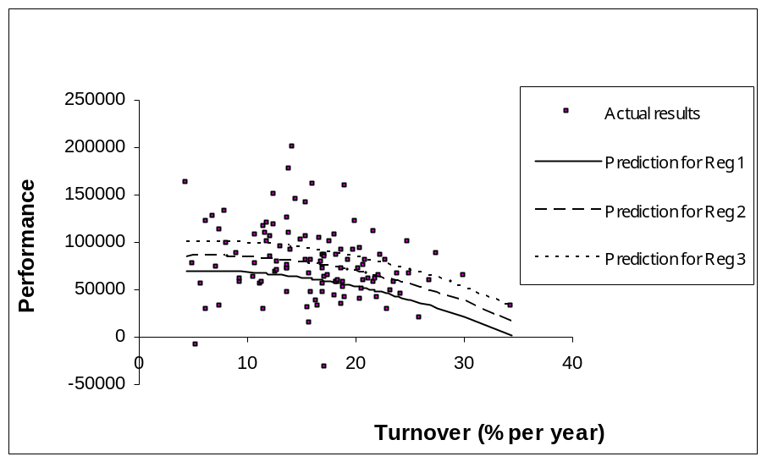

Figure 3: Predictions from data (bold) and 5 resamples for the model in Figure 1


